# LAB ASSIGNMENT

NAME: Aneeqa Altaf

Reg. No.: CIIT/SP20-BSM-007/ISB

Subject: Numerical Computation

Question 1: **Find the root of the following equation**

$$x^{3}-5x-9=0$$

**Graph:**

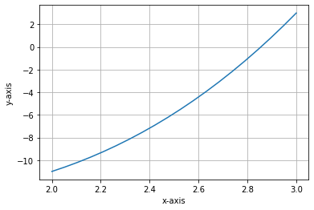

**BISECTION METHOD:**

**Table:**

|  |  |  |  |  |  |
| --- | --- | --- | --- | --- | --- |
| First initial guess (x1) | Second initial guess(x2) | F(x1) | F(X2) | C=(X1+X2)/2 | F(C) |
| **2** | **3** | **-11** | **3** | **2.5** | **-5.875** |
| **2.5** | **3** | **-5.875** | **3** | **2.75** | **-1.9531** |
| **2.75** | **3** | **-1.9531** | **3** | **2.875** | **0.3886** |
| **2.75** | **2.875** | **-1.9531** | **0.3886** | **2.8125** | **-0.8152** |
| **2.8125** | **2.875** | **-0.8152** | **0.3886** | **2.8437** | **-0.2215** |
| **2.8437** | **2.875** | **-0.2215** | **0.3886** | **2.8593** | **0.0809** |
| **2.8437** | **2.8593** | **-0.2215** | **0.0809** | **2.8515** | **-0.0718** |
| **2.8515** | **2.8593** | **-0.0718** | **0.0809** | **2.8554** | **0.003958** |
| **2.8515** | **2.8554** | **-0.0718** | **0.003958** | **2.85345** | **-0.0339** |
| **2.8534** | **2.8554** | **-0.0339** | **0.003958** | **2.8544** | **-0.0154** |

**Code:**

* # guess1 = 2, guess2 = 3
* from math import sin
* # implementation of bisection method
* def bisection(x0,x1,e):
* step = 1
* condition = True
* while condition:
* x2 = (x0+x1)/2
* print('iteration %d, x2 = %0.6f and f(x2)= %0.6f' %(step,x2,f(x2)))
* if f(x0) * f(x2) < 0:
* x1 = x2
* else:
* x0 = x2
* step = step +1
* condition = abs(f(x2)) > e
* print('root is :%0.8f '%x2)
* # return x2
* def f(x):
* return x**3-5*x-9 #using value of the funtion
* x0 = float(input('first guess: ')) # value of x1
* x1 = float(input('second guess: ')) # value of x2
* e = float(input('tolerance: '))
* if f(x0) * f(x1) > 0.0:
* print('given guess values do not bracket the root')
* else:

root = bisection(x0,x1,e)

Output:

* first guess: 2
* second guess: 3
* tolerance: 0.00001
* iteration 1, x2 = 2.500000 and f(x2)= -5.875000
* iteration 2, x2 = 2.750000 and f(x2)= -1.953125
* iteration 3, x2 = 2.875000 and f(x2)= 0.388672
* iteration 4, x2 = 2.812500 and f(x2)= -0.815186
* iteration 5, x2 = 2.843750 and f(x2)= -0.221588
* iteration 6, x2 = 2.859375 and f(x2)= 0.081448
* iteration 7, x2 = 2.851562 and f(x2)= -0.070592
* iteration 8, x2 = 2.855469 and f(x2)= 0.005297
* iteration 9, x2 = 2.853516 and f(x2)= -0.032680
* iteration 10, x2 = 2.854492 and f(x2)= -0.013700
* iteration 11, x2 = 2.854980 and f(x2)= -0.004204
* iteration 12, x2 = 2.855225 and f(x2)= 0.000546
* iteration 13, x2 = 2.855103 and f(x2)= -0.001829
* iteration 14, x2 = 2.855164 and f(x2)= -0.000641
* iteration 15, x2 = 2.855194 and f(x2)= -0.000048
* iteration 16, x2 = 2.855209 and f(x2)= 0.000249
* iteration 17, x2 = 2.855202 and f(x2)= 0.000101
* iteration 18, x2 = 2.855198 and f(x2)= 0.000027
* iteration 19, x2 = 2.855196 and f(x2)= -0.000011
* iteration 20, x2 = 2.855197 and f(x2)= 0.000008
* root is :2.85519695

Question 2: **Find the root of the following equation**

$$2x^{3}-9.5x+7.5$$

**Graph:**

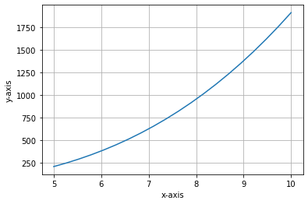

**NEWTON RAPHSON METHOD:**

**Table:**

|  |  |  |  |
| --- | --- | --- | --- |
| Initial guess(x0) | F(X0) | A=X-F(X)/F’(X) | F(A) |
| 5 | 210 | 3.5053 | 60.3422 |
| 3.5053 | 60.3422 | 2.5658 | 16.9067 |
| 2.5658 | 16.9067 | 2.0022 | 4.5320 |
| 2.0022 | 4.5320 | 1.6908 | 1.1046 |
| 1.6908 | 1.1046 | 1.5464 | 0.2054 |
| 1.5464 | 0.2054 | 1.5041 | 0.0165 |

**Code:**

* from math import sin
* def newton(fn,dfn,x,tol,maxiter):
* for i in range(maxiter):
* xnew = x - fn(x)/dfn(x)
* if abs(xnew-x)<tol:
* break
* x = xnew
* return xnew, i
* y = lambda x: 2*x**3-9.5*x+7.5
* dy = lambda x : 6*x**2-9.5
* x, n = newton(y, dy, 5, 0.0001, 100)

print('the root is %.3f at %d iterations.'%(x,n))

Output:

* the root is 1.500 at 7 iterations.

Question 3: **Find the root of the following equation**

$$x^{2}-sin^{2}\left(x\right)-4x+1$$

**Graph:**

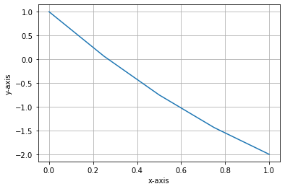

**REGULA FALSI METHOD:**

**Table:**

|  |  |  |  |  |  |
| --- | --- | --- | --- | --- | --- |
| First Initial guess(a) | Second initial guess(b) | F(a) | F(b) | C=(af(b)-bf(a))/f(b)-f(a) | F(c) |
| 0 | 1 | 1 | -2.7080 | 0.2696 | -0.0769 |
| 0 | 0.2696 | 1 | -0.0769 | 0.2504 | -0.00032 |
| 0 | 0.2504 | 1 | -0.00032 | 0.2503 | -0.000001 |
| 0 | 0.2503 | 1 | -0.000001 | 0.2503 | 0 |

**Code:**

* from math import sin
* def reg_falsi(f,x1,x2,tol=1.0e-6,maxfpos=100):
* if f(x1) * f(x2)<0:
* for fpos in range(1,maxfpos+1):
* xh = x2 - (x2-x1)/(f(x2)-f(x1)) * f(x2)
* if abs(f(xh)) < tol:
* break
* elif f(x1) * f(xh) < 0:
* x2 = xh
* else:
* x1 = xh
* else:
* print('No roots exists within the given interval')
* return xh, fpos
* y = lambda x: x**2 - sin(x)**2 - 4*x + 1
* x1 = float(input('enter x1: '))
* x2 = float(input('enter x2: '))
* r, n = reg_falsi(y,x1,x2)

print('The root = %f at %d false position'%(r,n))

Output:

* enter x1: 0
* enter x2: 1
* The root = 0.250324 at 4 false position

Question 4 **Find the root of the following equation**

$$2x^{2}-5x+3$$

**Graph:**

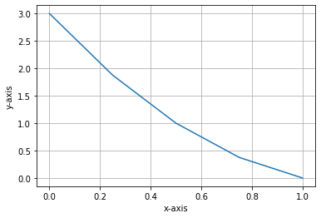

**SEACENT METHOD:**

**Table:**

|  |  |  |  |  |  |
| --- | --- | --- | --- | --- | --- |
| First initial guess(a) | Second initial guess(b) | F(a) | F(b) | Y=(a(f(b)-b(f(a))/(f(b)-f(a) | F(y) |
| -2 | 2 | 12.1731 | -3.8268 | 1.0432 | -2.8313 |
| -2 | 1.0432 | 12.1731 | -2.8313 | 0.4689 | -0.8603 |
| -2 | 0.4689 | 12.1731 | -0.8603 | 0.3059 | -0.2211 |
| -2 | 0.3059 | 12.1731 | -0.2211 | 0.2648 | -0.0577 |
| -2 | 0.2648 | 12.1731 | -0.0577 | 0.2541 | -0.01517 |
| -2 | 0.2541 | 12.1731 | -0.0577 | 0.2513 | -0.0039 |
| -2 | 0.2513 | 12.1731 | -0.0039 | 0.1802 | 0.2705 |
| 0.1802 | 0.2513 | 0.2705 | -0.0039 | 0.2503 | 0 |

**Code:**

* from math import sin
* def secant(fn,x1,x2,tol,maxiter):
* for i in range(maxiter):
* xnew = x2 - (x2-x1)/(fn(x2)-fn(x1))*fn(x2)
* if abs(xnew-x2) < tol:
* break
* else:
* x1 = x2
* x2 = xnew
* else:
* print('warning: Maximum number of iterations is reached')
* return xnew, i
* f = lambda x: 2*x**2 - 5*x + 3
* x1 = float(input('enter x1: '))
* x2 = float(input('enter x2: '))
* r, n = secant(f,x1,x2,1.0e-6,100)

print('Root = %f at %d iterations'%(r,n))

Output:

* enter x1: -2
* enter x2: 2
* Root = 1.500000 at 8 iterations